

Holiday Festival
December 21 & 22, 2024

Practice & Registration Starts At 9:00 AM

600 registered targets
FEES per day --ata - $4.00 & asta - $3.00
WHITE FLYER targets will be thrown
voice-activated pullers

>>>>>>>>>>>>>>>>>>>>>>>>

directions to shooting grounds Take I-19
freeway south to ajo road turn west
for 8 miles to san joaquin turn north
on san joaquin & follow the signs
club phone # {520} 883-6426

>>>>>>>>>>>>>>>>>>>>>>>>>>
trailer spaces available for members
with Full hookups

check in at the club office

>>>>>>>>>>>>>>>>>>>>>>>>>>>>
café will be open at 7:00 am
for breakfast & lunch

Saturday
December 21, 2024

Practice & registration starts at 9:00 AM
Event #1 starts at 10:00 AM
All ties will be carried over to the next like event.
Saturday’s winners of each Class will be ADVANCED

Event #1 – Fireplace Singles

100 Singles Targets $48.00

OPTIONS
1. Lewis Purse (2 classes) $10.00

(Divided 60/40)

Gift Certificates to winner of each class and category
(AA, A, B, C, D)
Lady, Jr., Vet, Sr. Vet

~~~~~~~~~~~~~~~~~~~~~~~~~~~~~~~~~~~~~~~~~~~~~~~~~~~~~~~~
Event #2 – Christmas Gift Handicap

100 Handicap Targets $48.00

OPTIONS
- Lewis Purse (2 classes) $10.00
(Divided 60/40)

Gift Certificates to winner of each yardage group and category
{18-21} {22-24} {25-27}
Lady, Jr., Vet, Sr. Vet

~~~~~~~~~~~~~~~~~~~~~~~~~~~~~~~~~~~~~~~~~~~~~~~~~~~~~~~~

Event #3 – Fudge Doubles
50 Pair Doubles Targets $48.00

OPTIONS
1. Lewis Purse (2 classes) $10.00
(Divided 60/40)

Gift Certificates to winner of each class and category
(AA, A, B, C, D)
Lady, Jr., Vet, Sr. Vet

You are cordially invited to participate in our
Holiday Festival and upcoming registered shoots.

Upcoming Registered Shoots in 2025

January 2-5 – Fun in the Sun
January 22-26 – Winter Chain Pin Shoot
February 19-23 – Preliminary Spring Grand
February 24-March 2 – Spring Grand American
March 25-33 – Arizona State Shoot

One day shoots:
April 19
May 19
June 15
July 14
August 18

~~~~~~~~~~~~~~~~~~~~~~~~~~~~~~~~~~~~~~~~~~~~~~~~~~~~~~~~~~
REGISTRATION CERTIFICATE
This certifies that the Tucson Trap & Skeet Club is authorized to hold a registered shoot at Tucson, Arizona on December 21 & 22, 2024. The Amateur Trapshooting Association rules will govern this shoot and the scores will be included in the official records.
The Amateur Trapshooting Association

Targets may be cross registered to PITA subject to all fees, rules and requirements.

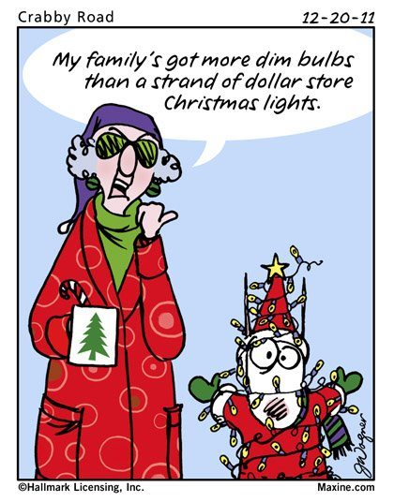

Sunday
December 22, 2024

Practice & registration starts at 9:00 AM
Event #4 starts at 10:00 AM

Event #4 – Reindeer Singles

100 Singles Targets $48.00

OPTIONS
1. Lewis Purse (2 classes) $10.00

(Divided 60/40)

Gift Certificates to winner of each class and category
(AA, A, B, C, D)
Lady, Jr., Vet, Sr. Vet

~~~~~~~~~~~~~~~~~~~~~~~~~~~~~~~~~~~~~~~~~~~~~~~~~~~~~~~~

Event #5 – Santa Claus Handicap

100 Handicap Targets $48.00

OPTIONS
- Lewis Purse (2 classes) $10.00
(Divided 60/40)

Gift Certificates to winner of each yardage group and category
{18-21} {22-24} {25-27}
Lady, Jr., Vet, Sr. Vet

~~~~~~~~~~~~~~~~~~~~~~~~~~~~~~~~~~~~~~~~~~~~~~~~~~~~~~~~

Event #6 – Egg Nog Doubles
50 Pair Doubles Targets $48.00

OPTIONS
1. Lewis Purse (2 classes) $10.00
(Divided 60/40)

Gift Certificates to winner of each class and category
(AA, A, B, C, D)
Lady, Jr., Vet, Sr. Vet

Gift Certificates will be awarded. Please pick them up after shooting each day or between events.

Notice

By the act of classifying and participating, each shooter has indicated they assume and accept full responsibility for themselves and their minor children, for bodily injury, death, loss of personal property and expenses as a result of inherent risks and dangers.

Notice

Junior and Sub Junior targets will be billed at $25.00 per 100. No Options will be allowed for reduced price shooters.

Information for the Spring Satellite Grand American

Pre-squadding will open on December 21, at 11:30 AM MST.

There will be a pre-cashier form available on the Club’s website for the Spring Grand.

Go to tucsontrapandskeet.com then click on Events, select ‘trap events’, select ‘2025 events’, then under Spring Satellite Grand American click on download pre-cashier form.

The dates are February 19 to March 2, 2025. Pre-cashiering must be in the Club’s hands by closing Monday, February 17.



